21IPC501J
RESEARCH METHODOLGY

LABORATORY EXERCISE REPORT
(Academic Year: 2025-2026)

NAME :
REGISTER NUMBER :
YEAR : I
SEMESTER : I

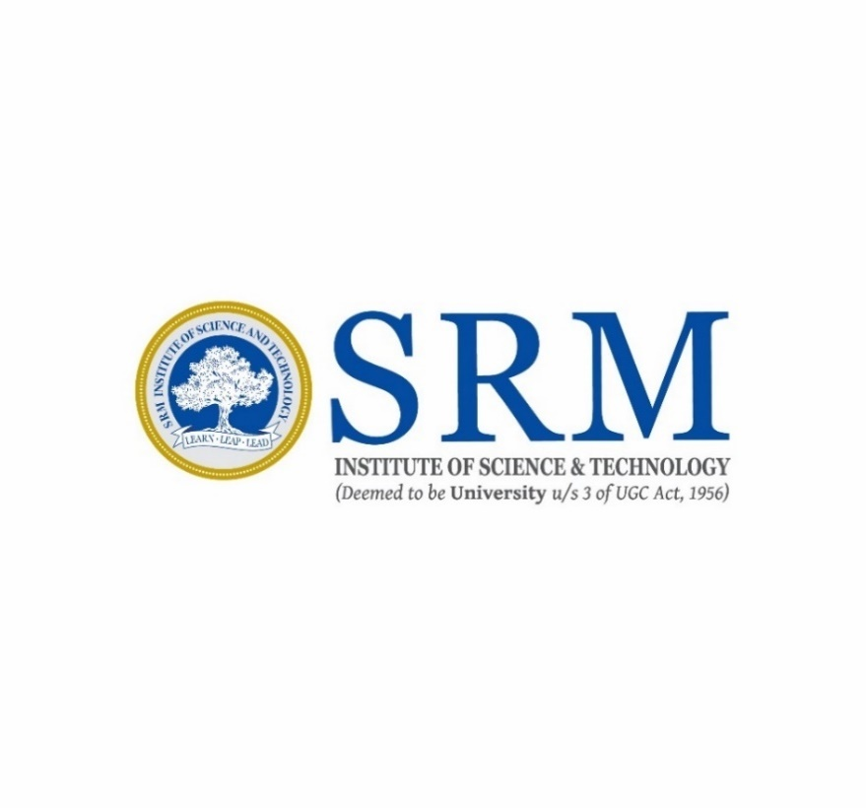
DEPARTMENT OF ELECTRICAL & ELECTRONICS ENGINEERING
COLLEGE OF ENGINEERING AND TECHNOLOGY
SRM INSTITUTE OF SCIENCE AND TECHNOLOGY
KATTANKULATHUR-603203
SRM INSTITUTE OF SCIENCE & TECHNOLOGY
(under Section 3 of UGC Act, 1956)
SRM NAGAR, KATTANKULATHUR
CHENGALPATTU DISTRICT-603 203

BONAFIDE CERTIFICATE

Register No : -----------------------

Certified to be the bonafide record of work done by ________________________ of EIE M.Tech Degree course in the Practical 21PC501J – Research Methodology in SRMIST, Kattankulathur during the academic year 2025-2026

Date: Course Coordinator

INDEX
S.NO | D.O.E | Name of the Exercise | Marks | Signature
1

2

3

4

5

6

7

8

9

10

